Exercise 10
Marc Dotson
- Simulate sales data as a function of promotional spend using a regression. Name the observed variables sales and promotional_spend. Use different parameter values than we did in class.
- Visualize the simulated data and add the best fitting line using geom_smooth().
- Fit the regression using {tidymodels}.
- Render the Quarto document into Word and upload to Canvas.
Five points total, one point each for:
- Replacing y with sales and x with promotional_spend.
- Using parameter values other than beta0 = 3 and beta1 = 7.
- Visualizing the simulated data with geom_smooth(method = “lm”).
- Fitting the regression using {tidymodels}.
- One point for submitting a rendered Word document.

Simulate Data
Let’s load the {tidyverse} and {tidymodels}, set the simulation seed, specify the parameter and variable values, and simulate sales data using a regression.
# Load packages.
library(tidyverse)
── Attaching core tidyverse packages ──────────────────────── tidyverse 2.0.0 ──
✔ dplyr 1.1.4 ✔ readr 2.1.4
✔ forcats 1.0.0 ✔ stringr 1.5.1
✔ ggplot2 3.4.4 ✔ tibble 3.2.1
✔ lubridate 1.9.3 ✔ tidyr 1.3.0
✔ purrr 1.0.2
── Conflicts ────────────────────────────────────────── tidyverse_conflicts() ──
✖ dplyr::filter() masks stats::filter()
✖ dplyr::lag() masks stats::lag()
ℹ Use the conflicted package (<http://conflicted.r-lib.org/>) to force all conflicts to become errors
library(tidymodels)
── Attaching packages ────────────────────────────────────── tidymodels 1.1.1 ──
✔ broom 1.0.5 ✔ rsample 1.2.0
✔ dials 1.2.0 ✔ tune 1.1.2
✔ infer 1.0.5 ✔ workflows 1.1.3
✔ modeldata 1.2.0 ✔ workflowsets 1.0.1
✔ parsnip 1.1.1 ✔ yardstick 1.2.0
✔ recipes 1.0.9
── Conflicts ───────────────────────────────────────── tidymodels_conflicts() ──
✖ scales::discard() masks purrr::discard()
✖ dplyr::filter() masks stats::filter()
✖ recipes::fixed() masks stringr::fixed()
✖ dplyr::lag() masks stats::lag()
✖ yardstick::spec() masks readr::spec()
✖ recipes::step() masks stats::step()
• Use tidymodels_prefer() to resolve common conflicts.
# Set the simulation seed.
set.seed(42)
# Specify the parameter and variable values.
nobs <- 300
beta0 <- 5
beta1 <- 12
# Simulate data using the regression model.
sim_data <- tibble(
promotional_spend = runif(nobs, min = 0, max = 10),
sales = beta0 + beta1 * promotional_spend + rnorm(nobs, mean = 0, sd = 3)
)
sim_data
# A tibble: 300 × 2
promotional_spend sales
<dbl> <dbl>
1 9.15 115.
2 9.37 113.
3 2.86 42.8
4 8.30 104.
5 6.42 80.6
6 5.19 63.6
7 7.37 93.4
8 1.35 18.8
9 6.57 82.2
10 7.05 93.5
# ℹ 290 more rows
Our simulated data consists of an explanatory variable promotional_spend drawn from a random uniform distribution (values between 0 and 10) and a response variable sales equal to beta0 plus beta1 times promotional_spend plus an error term, which are drawn from a random normal distribution (mean 0 and standard deviation 3).

Visualize the Simulated Data
# Visualize the simulated data.
ggplot(sim_data, aes(x = promotional_spend, y = sales)) +
geom_point(alpha = 0.5) +
geom_smooth(method = "lm") +
labs(
title = "Simulated Data"
)
`geom_smooth()` using formula = 'y ~ x'
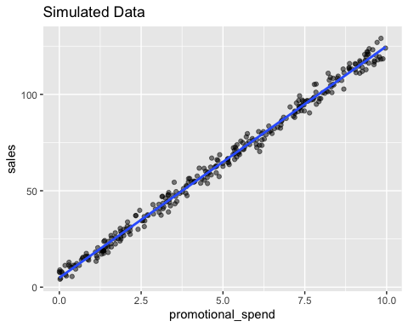
This data clearly follows a line, which isn’t surprising since we’ve simulated it that way.

Fit the Model
# Fit the model.
linear_reg() %>%
set_engine("lm") %>%
fit(sales ~ promotional_spend, data = sim_data)
parsnip model object
Call:
stats::lm(formula = sales ~ promotional_spend, data = data)
Coefficients:
(Intercept) promotional_spend
4.897 12.011
As you can see, the estimate for beta0, the intercept parameter, is close to 5, the value we specified. Similarly, the estimate for beta1, the slope parameter associated with promotional_spend, is close to 12, the value we specified.

